In El Paso, the Rio Grande slowed down each evening from the 12th to the 21st of January.

The river saw its highest flows in the beginning of the period analyzed with the slowest rates of flow towards the end of the period, showing a gradually decreasing trend.

USGS monitoring alerts sent each time the river flow dropped below 15 cubic feet per second revealed a gradual decrease in flow during the period analyzed. Additionally, the data showed 5pm as the most common time for reductions in rate of flow. The latest time the stream saw this reduction was at 7pm during this period, which only occurred once on the 21st of January. Alerts were sent each day from the 12th to the 21st, detailing the date and times at which the measurements were taken.

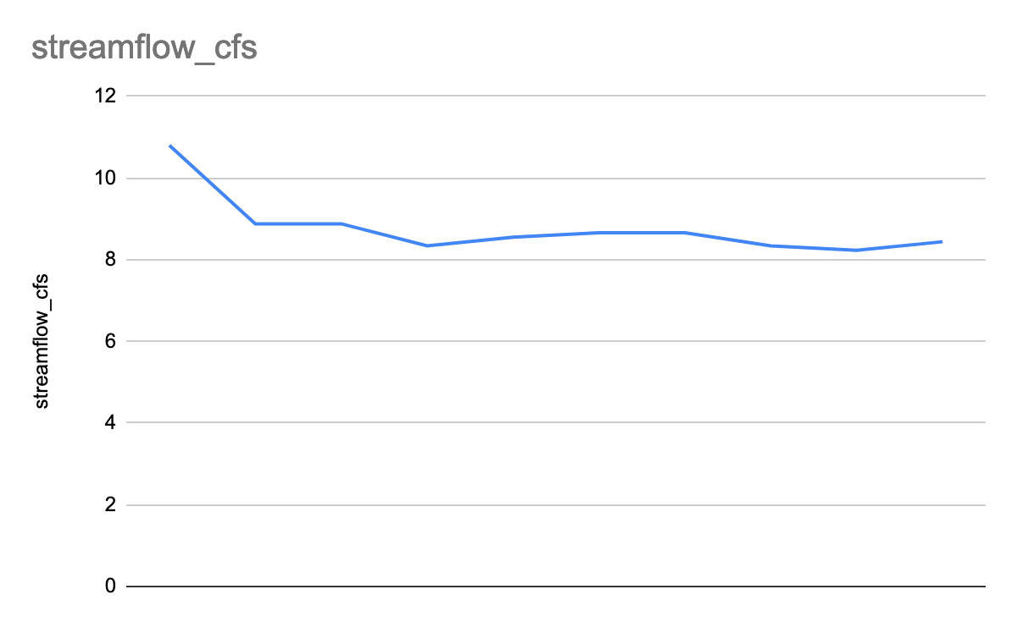

El Paso Times [reported](https://www.elpasotimes.com/story/news/2021/12/29/el-paso-wastewater-pipeline-constructed-end-flow-sewage-rio-grande/9049068002/) on December 29th that a replacement project for a damaged wastewater line had been completed and that wastewater would continue to discharge into the river in gradually smaller amounts for the next several weeks afterwards. The wastewater line had originally been dumping sewage into the river since August.

During the period analyzed, the river ran the fastest on the 12th at a rate 10.8 cubic feet per second or 2.64 cubic miles per hour. The river ran the slowest on the 20th at a rate of 8.23 cubic feet per second or 2.01 cubic miles per hour. The average flow from the 12th to the 21st was 8.78 cfs or 2.15 cmph.

<https://docs.google.com/spreadsheets/d/1LjJFjFlc5dLez3QmHIU3B2XOV6WV8V5p-kqQLTeK1yo/edit?usp=sharing>